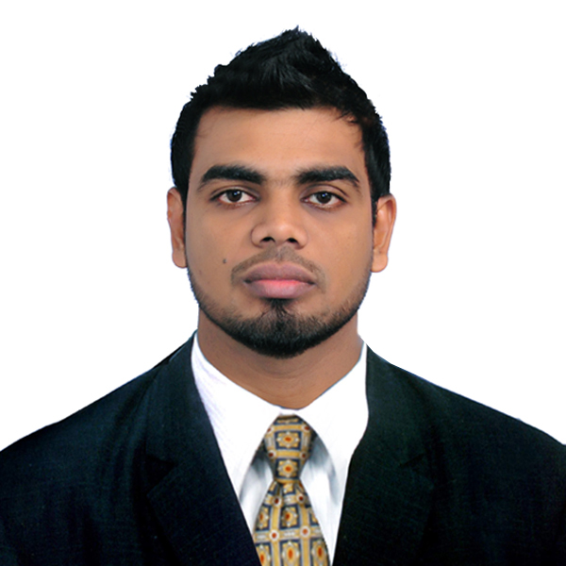
N.M.D.M.B.Kosgahakumbura
85/12A, Henegedara lane
Maharagama
Mobile: 0773362699
email: dilan0425@yahoo.com
CAREER GOALS AND OBJECTIVES

- Exposure myself to challenging business environment with substantial competencies of knowledge, skills & attitudes and contributing to the success of the organization’s business & Operation strategies and moreover formulate innovative strategies in field of business & operation to enhance the efficiency and effectiveness of the field.
WORKING EXPERIENCE

- Worked as a Management Trainee at Kanrich Finance. Ltd since 15th of September 2014 and promoted as a senior executive (Finance department) -01st January 2016.
- Preparing Management Information (MIS) report for monthly board meetings.
- Preparing monthly Profit & loss accounts for company & branches.
- Preparing Annual report Financial Analysis.
- Preparing monthly efficiency ratios for company.
- Worked as an In-plant trainee at MAS Active -Synergy Pvt. Ltd since 02.01.2014 - 25.05.2014.
PROFESSIONAL QUALIFICATIONS
- Completion of professional qualification (PQHRM) in Human Resources Management at Institute of Personal Management (IPM) Sri Lanka.
- Completion of Diploma in Banking and Finance Course (DBF) at Institute of Bankers Sri Lanka.
- Completion of certificate in Banking and Finance Course (CBF) at Institute of Bankers Sri Lanka.
EDUCATIONAL QUALIFICATIONS

- Graduate of BSc (special) Financial Management Degree program (Department of Accountancy & Finance) Faculty of Management Studies at Sabaragamuwa University of Sri Lanka.
- G.C.E Advanced level examination (2008) got through in Commerce stream with 3- A passes. Examination no-5226813.
- G.C.E Ordinary level examination (2003) got through with 2-A passes, 3-B pass & 4-C passes. Examination no-30056098.

LEADERSHIP SKILLS

- Captain of the Sabaragamuwa University Basketball team 2012.
- Captain of the Old Anandians Basketball team since 2007.
- Captain of the Urban Youth Basketball Team 2011/2012.
- Captain of the Ananda College U19 Basketball team 2004/2005.
- Treasure of the Sabaragamuwa University Sports Council 2011.
EXTRA CURRICULAR ACTIVITIES

- Member of the Kanrich Finance. Ltd Basketball Team 2015.
- Member of the Sri Lanka Universities Basketball Team 2010/2011.
- Member of the Sabaragamuwa University Basketball team.
- Member of the Sabaragamuwa University sports Council.
- Member of the Ananda college Basketball team (1999-2005)
- Member of the Ananda College Agriculture Society.
- Member of the Ananda College Eastern music Circle.
- Member of the Ananda College Drama Circle.
Special achievements
- Champions of the 25th Mercantile “D” Division Basketball Tournament 2015 & became top scorer of the final.
- Sri Lanka Universities Basketball (SLUSA) Colour holder 2011, 2012, 2013.
- Sabaragamuwa University Basketball Colour holder 2010, 2011, 2012.
- Best Defensive player of the “Leadership trophy” Inter University Basketball Tournament 2013.
- Champions of the “Leadership trophy” Inter University Basketball Tournament 2013.
- Participated to a Basketball tournament organized by Basketball association of Malaysia 2013.
- Participated to the outbound training program conducted by the Academy of Adventure (AOA) 2013.
- Champions of the senior Nationals “B” Division Basketball Tournament 2011.
- Champions of the Colombo District Youth Basketball Tournament 2011.
- Champions of the U17 All Island “B” Division Basketball Tournament 2002.
- 2nd Runner-up of the U 17 All Island “A” Division Basketball Tournament 2003.
- 2nd Runner-up of the U 13 All Island “A” Division Basketball Tournament 1999.
- Runner up of the MORA Invitational Basketball Tournament 2009.
- 2nd Runner up of the U19 Zonal Basketball Tournament 2005.
- 2nd Runner up of the U17 Zonal Basketball Tournament 2003.
SKILLS & COMPETENCIES

- An excellent team member who is willing to work in a group and a proven record of leadership.
- Good computer skills and ability to work with general computer packages.
- Ability to learn new skills quickly & adapt to different environments with confidence.
- Good analytical and Decision making skills.
PERSONAL DETAILS

- Date of Birth : 25th of April 1987
- Sex : Male
- Marital Status : Single
- School Attended : Ananda College, Colombo 10.
: Uva College, Badulla
- N.I.C Number : 871160619V
- License Number : B738120
REFEREES

Mr. R.P.D.K.Rathnasinghe, Mr. Y.P.Warnasekara,
Assistant General Manager, Assistant General Manager- HR,
Bank of Ceylon, Bank of Ceylon,
Western Province- North, Head Office,
Colombo. Colombo.
Mobile: 0773442524 Mobile: 0777275781

Certificates and testimonials would be produced at the interview for further confirmation. I do here by certify that the particular submitted by me are true and correct to the best of my knowledge.

N.M.D.M.B.Kosgahakumbura 23/02/2016

